TD 5G NR
Exercise 1: 5G NR features
What is, in your opinion, the main factors that make that 5G NR provides a better throughput than LTE and LTE-A?
Larger Bandwidths: While LTE-A supports up to 20 MHz per carrier, 5G NR supports up to 400 MHz per carrier.
Enhanced Carrier Aggregation: 5G NR allows the aggregation of up to 16 carriers (maximum bandwidth of 6.4 GHz), compared to only 5 in LTE-A.
Flexible Numerology: Scalable subcarrier spacing (15, 30, 60, 120 kHz) allows the network to adapt to different services and frequencies.

Exercise 2: Throughput computation
Orange France uses a frequency band of 90MHz in the 3.5Gz spectrum band for the deployment of its 5G NR network. The frequency band is organized into 3000 subcarriers of 30KHz in FDD mode.
What is the maximum theoretical downlink data rate that can be provided by Orange under good radio conditions allowing the use of 256-QAM modulation (normal cp mode)?

1 ts = 0.25ms = 7 symbols = 7*8 bits => 56 bits
Data rate of 1sec = 56/0.25 => 224 kbps
Data rate of downlink = 224 * 3000 => 672 Mbps

Exercise 3: Antenna configuration
5G NR gives many options that allow a better adaptation of the network for the corresponding environment. Using arrows propose for each class of environment, the adequate frequency band, subcarrier wideband and cyclical mode.

Environment | Frequencies | Subcarrier size | Cyclical mode
Paris-centre + dense network  Montbéliard + dense network  Montbéliard + low dense net.  A36 Belfort-Montbéliard  Saint-Jean-Pied-de-Port | 700MHz  3.5GHz  24GHZ | 15KHz  30KHz  60KHz | Normal  Extended

Environment | Frequency | Subcarrier Size | Cyclical Mode
Paris-centre + dense network | 3.5 GHz | 15 kHz | Normal
Montbéliard + dense network | 24 GHz | 30 kHz | Normal
Montbéliard + low dense net. | 3.5 GHz | 60 kHz | Extended
A36 Belfort-Montbéliard | 700 MHz | 60 kHz | Extended
Saint-Jean-Pied-de-Port | 700 MHz | 15 kHz | Extended

Exercice 4. 5G NR Throughput according to the CQI
Hereafter the correspondence table between the SINR observed by the UE and the CQI.
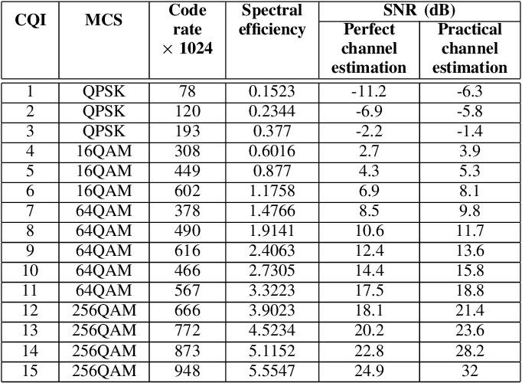
- Calculate the provided 5G NR downlink throughput if the available BW is of 70 MHz, the frequency band is of 4.6GHz, the cyclic prefix mode is extended, the transmission power of the antenna is of 43dBm, the distance of the UE from the antenna is of 1400m. The subcarrier size is of 15kHz. The computing should consider the nose+interference (= -100dBm), and the free space propagation model (loss = 32,45 dB + 20*log [frequency (MHz)] + 20*log [distance (km)]).
Received Signal = 43dBm – Loss => 43 – 32.45 dB + 20*log [4600] + 20*log [1.4]
So, RS = -65.12dBm
SINR = -65.12 – 100 => 35db
1 ts = 0.5ms => 6 symbols => 6*8 bits => 48 bits
1 subcarrier data rate = 96 kbps
Data rate = 4660 * 96 kbps = 447Mbps
Utile Data rate = 447 * 968/1024 => 413Mbps

- What is the useful download throughput?

